March 2023 – Mini Toolkit
Welcoming New Chapter Members

We want to provide you, our chapter leaders, with the best resources to help your membership marketing efforts around recruitment, engagement, and retention. Towards that goal, this month’s Toolkit focuses on ways to welcome new members to your chapter. According to Kaiser Insights & Dynamic Benchmarking’s 2023 New Member Engagement Study, welcome emails and phone calls/voice mails are the most popular and effective ways to engage new members. This month’s Toolkit provides Email and Phone Call/VM Templates to help you in your engagement efforts.

Toolkit Resources for Welcoming New Members
- Sample Emails
- Sample Phone Call/VM Script
- Pulling a list of New Members from the Chapter Portal

Welcoming New Members to Your Chapter
Sample Emails

Template #1 - State Advocacy Focus
Template #2 - Events/Membership Benefits Focus

Template #1 – State Advocacy Focus

Subject Line: Welcome to [CHAPTER NAME], [Dr. LAST NAME]

[CHAPTER NAME], recently received notice from national ACEP that you have joined, and, therefore, are now a member of our state Chapter. We want to personally welcome you to our Chapter, and extend an invitation to contact us [hyperlink/insert chapter email address] at any time.
Emergency physicians face a number of challenges at the state level. [CHAPTER NAME], has been battling successfully on behalf of emergency physicians to address a multitude of issues that affect our patients and our profession. Recently, we [insert recent accomplishments through state advocacy efforts]. We are also actively working to [insert current efforts]. We are always working to represent the concerns and challenges of the emergency physician. [Optional: You can read more about our wins and efforts here [hyperlink/insert link to page on your website if applicable, otherwise remove.]]. Your involvement in [CHAPTER NAME] strengthens our voice.
Again, welcome to [CHAPTER NAME]! Of course, we are always recruiting members to become active in the Chapter. If you have the desire to do so, please let us know.
Sincerely,
[Your name]
[Your title]
[Email address, phone number]

Template #2 – Events/Membership Benefits Focus

Subject Line: Welcome to [CHAPTER NAME], [Dr. LAST NAME]

Greetings, [Dr. LAST NAME],
Thank you so much for joining [CHAPTER’s name]! We’re thrilled to have you as a member and can’t wait to get to know you.
To help you get involved, here are a few events we have planned over the next couple of months:
- [List upcoming events here]
- [Tip: Formatting them as a bulleted list helps readers skim!]
You can view our full calendar of events at [link to a website with an event calendar].
[ADVOCACY SUGGESTIONS: If your state is active on the advocacy front, consider incorporating some information about your state’s advocacy efforts such as …
The (State) College of Emergency Physicians has more than # members in the state.
For the past ____ years, we have held a Legislative Day (Name of Your Event) in _______ (State Capital).
We have accomplished the following through our advocacy efforts:
- Bullet 1 - List achievement
- Bullet 2 - List achievement
- Bullet 3 - List achievement
We invite you to learn more about the issues affecting EPs in our state and get involved.
Other suggested text:
We encourage you to attend the Board of Directors/Membership meetings and become involved with our chapter. All of our meetings are open to all members, which will not only allow you to familiarize yourself with the issues but get to know your colleagues from across the state.
Are there any particular issues you want us to address that are important to you or your practice setting?
Remember, we are YOUR professional society].
In addition, we want to make sure you’re taking full advantage of all the membership benefits available. Here are a few other things to get started with ASAP. In addition, visit ACEP in Action to see how ACEP works on your behalf.
- [List primary membership benefits, i.e. networking opportunities, access to members-only content, professional development opportunities, etc.]
Optional: We’ll follow up with a phone call soon, so we look forward to connecting with you soon! See the accompanying sample voicemail script.
Should you have any questions or comments about your membership or benefits, please contact us at [phone number] or email us at [email address].
We look forward to seeing you at our next meeting on [include date (if applicable). [OR We look forward to meeting you soon at one of our future events!]
Sincerely,
[Your name]
[Your title]
[Email address, phone number]

Welcoming New Members to Your Chapter
Sample Phone Call/Voicemail Script

Phone Call Script
Voicemail Script

Use this script if you get them live:

Hi [DR. LAST NAME],

This is [Name], [Role (i.e.: President or Board Member, etc.)] of the [Chapter] of ACEP.

How are you today?

I am calling to welcome you to the [____________] Chapter and introduce myself. I work at [__________] [add any other piece of information about yourself that you deem relevant].

I would love to know more about your areas of interest and what keeps you up at night and how we may be able to help.

[Wait for response.]

Did you have any questions for me about the chapter, our activities, or what we’re doing on any specific issues?

[Wait for response.]

[If they don’t have any questions, wrap up the phone call being respectful of their time]

Again, my name is [____________] and on behalf of [____________], I look forward to meeting you at one of our future events [specify event details if applicable].

We appreciate your membership, and thanks again!

Use this script if leaving a voice mail:

Hi [DR. LAST NAME],

This is [Name], [Role (i.e.: President, Board Member, etc.)] of the [Chapter] of ACEP.

I wanted to take a moment to welcome you personally as a new chapter member. We’re thrilled to have you join us and look forward to meeting you at one of our upcoming events [insert specifics as needed].

Look out for regular emails from the chapter and please feel free to contact me at [insert contact information] (speak slowly when leaving your phone number or email address) if you have any questions about what we’re doing on specific issues or want to get involved.

Again, thank you for joining, and welcome!

Have a good day!

Pulling a list of New Members from the Chapter Portal

Log in to the chapter portal at https://webapps.acep.org/chapterportal/

- Go to the Reports tab
- Download the Member Extract report
- Open the file in Excel
- Go to the Data tab, then click on ‘Filter’
- Click on the Join Date (column AA) filter arrow
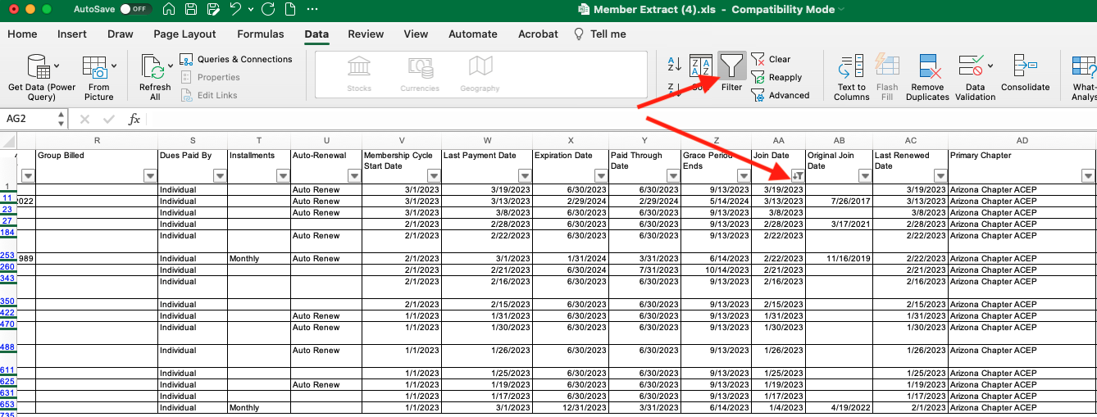

- Sort by Descending order so the latest join date is at the top. You can further filter by year or month as needed. Click the red X/button to exit the filter pop up window.
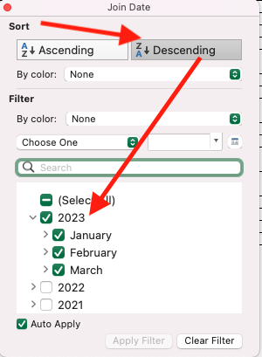
- If you want to customize your outreach, you can further segment the list by filtering on fields such as Member Type: Candidate vs. Regular (column N) or Member Rate: Medical Student, Resident, NewYear1, Regular, Retired, etc. (column O).

