Social Media Graphic Posts

To prevent getting very sick from COVID, timing is everything.
Copy:  FDA-authorized/approved treatments can help prevent severe illness from #COVID19. But you must begin taking them within days of when your symptoms start. Even if your symptoms are mild, treating COVID early could save your life.  Learn more at cdc.gov/COVIDTreatment  #WeCanDoThis  Image:  [TBD]  Text on image:  To prevent getting very sick from COVID, timing is everything. | 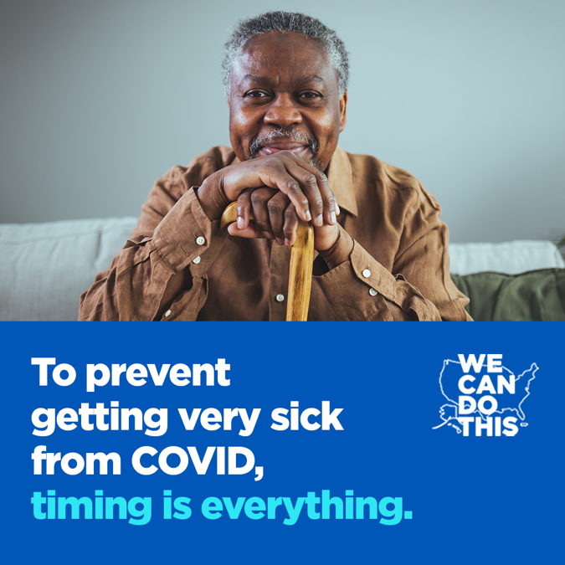  Facebook and Instagram (1080 x 1080 pixels)
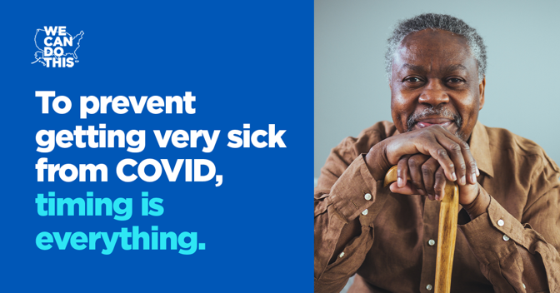
Twitter (1200 x 628 pixels)

Know your risk for getting very sick from COVID.
Copy:  You’re more likely to get very sick from #COVID19 if you’re 50 or older or if you have certain health issues. Talk to your doctor about your risk and available treatments to help prevent severe illness from COVID.  Learn more at cdc.gov/COVIDTreatment  #WeCanDoThis  Image:  [TBD]  Text on image:  Know your risk for getting very sick from COVID. | 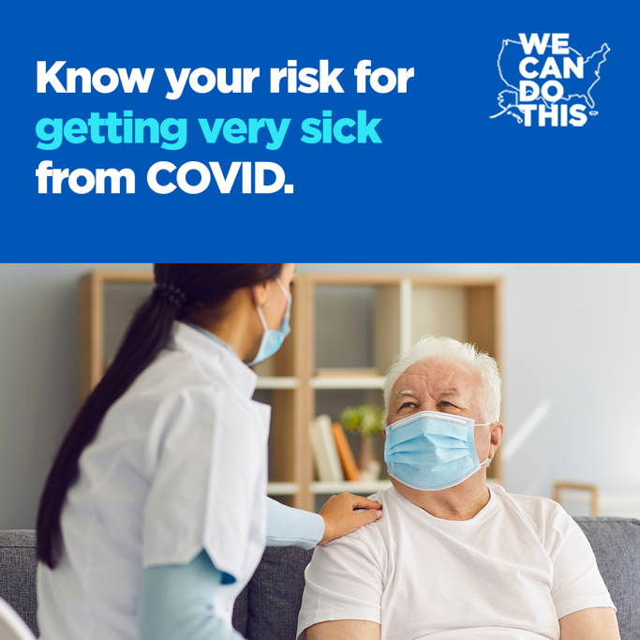  Facebook and Instagram (1080 x 1080 pixels)
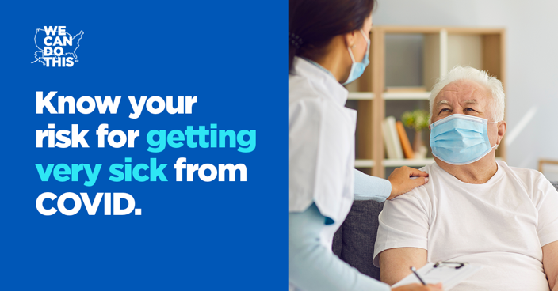
Twitter (1200 x 628 pixels)

Think you have COVID? Get tested right away!
Copy:  Even if your #COVID19 symptoms are mild, getting an FDA-authorized/approved COVID treatment from a doctor within days of when your symptoms start can help keep you out of the hospital. It could even save your life.  Learn more at cdc.gov/COVIDTreatment  #WeCanDoThis  Image:  [TBD]  Text on image:  Think you have COVID? Get tested right away! | Facebook and Instagram (1080 x 1080 pixels)  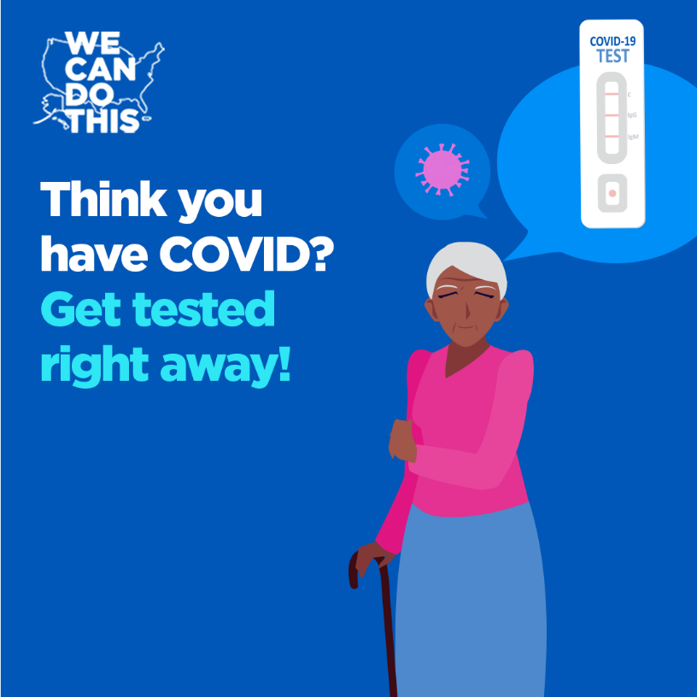
Twitter (1200 x 628 pixels)

